**MOVIE NIGHT – UNDER THE STARS**

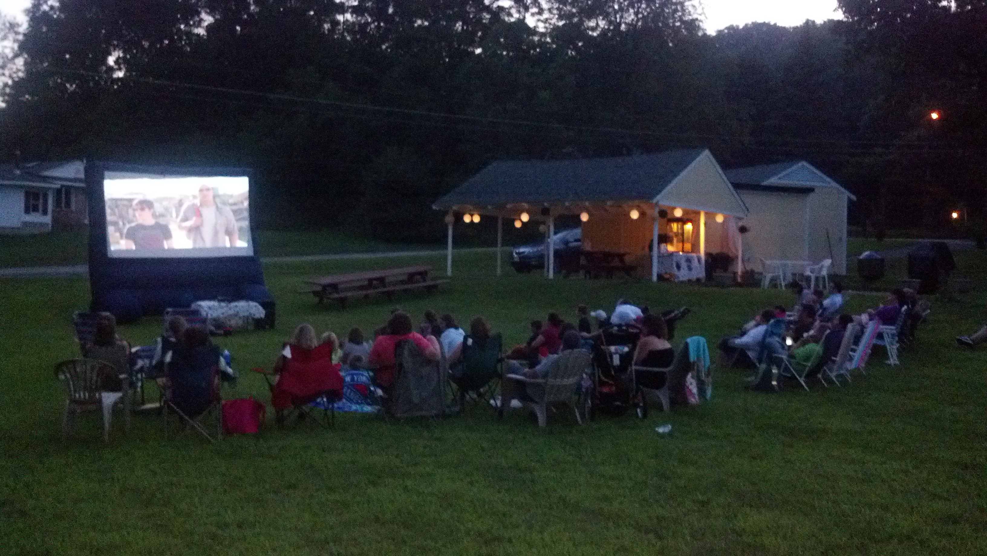

On August 2, Seneca Lake Club held the first ever outdoor movie night. Over 50 people came out to enjoy Journey 2: The Mysterious Island. A sunset over the lake provided the backdrop, as the movie was shown on a 12’ inflatable screen. Blankets, lawn chairs, and strollers were set up next to the pavilion and free popcorn was provided as the kids and parents alike enjoyed a wonderful summer night under the stars. A special Thank You to Annelie Schreck for coordinating the event!

**Annual Meeting and BBQ!!!**

**Sunday, August 26th at 1pm**

Please join us at the beach for our Annual Meeting followed by a BBQ to Celebrate Our New Beginning! After the annual meeting which will include voting for Board Members and outgoing Trustees, presentation of the budget, and updates on the general happenings of the club, please stay and enjoy food, music, swimming, games, and ice cream sundaes for the kids. Hamburger, hot dogs and sodas will be provided. Please bring a dish to share. Open to all members in good standing and their families. Childcare will be available during the meeting. Please RSVP on the Evite or call Annelie Schreck (contact info below).

**Questions: Call or email Annelie Schreck**

**(973) 270-5839, lieschreck@yahoo.com**

C:\Users\thomas.emanski\AppData\Local\Microsoft\Windows\Temporary Internet Files\Content.IE5\MGJ7AM1Z\MC900301314[1].wmf

C:\Users\thomas.emanski\AppData\Local\Microsoft\Windows\Temporary Internet Files\Content.IE5\USTAVST4\MC900351221[1].wmf

**Join us on Facebook**

http://www.facebook.com/senecalakebeachclub.spartaNJ



**New & Improved Seneca Lake Website**

The new club website is now up and running! Please visit: **SenecaLakeClub.org**

On the new website you will find a history of the lake, calendar of events, online versions of The Smoke Signal, photos, membership information, and links to our Facebook page.

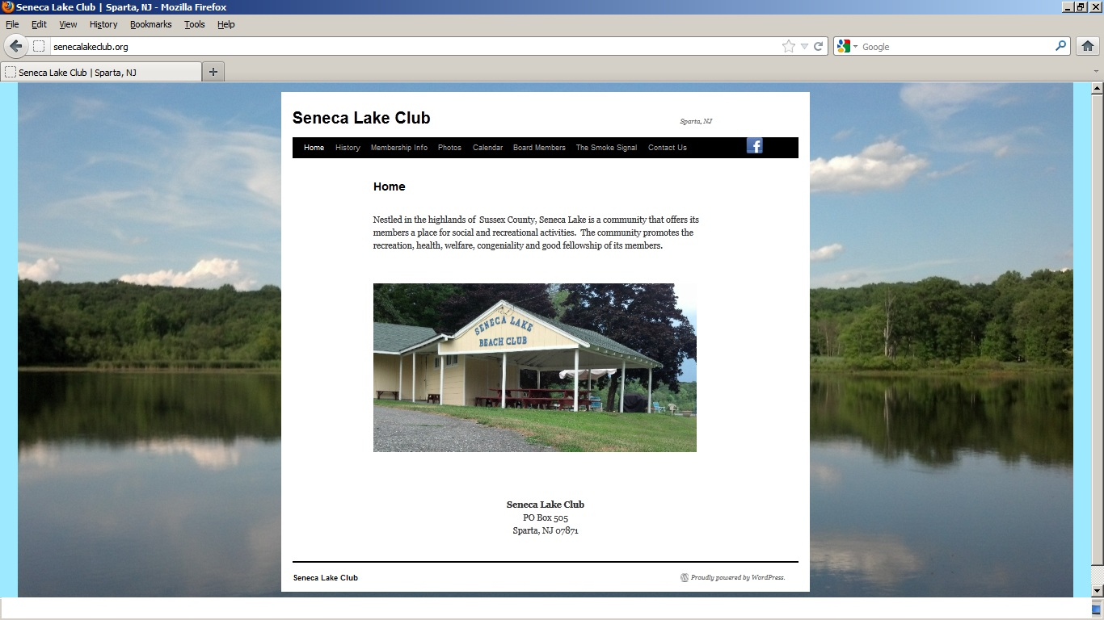

**Upcoming Events**

* **Annual Meeting – August 26**
* **Beach Clean-Up – September TBD**
* **Fall Clothing Drive – October 13**
* **Halloween Party/Trick-or-Treat – October 31**

Be sure to check The Smoke Signal or the calendar located on the new website for exact dates, times, and information regarding upcoming events.

**Seneca Lake Goes Green**

The August edition of the Smoke Signal will be the last hard copy delivered directly to your mailbox. Due to printing costs and an increased awareness of our environment, the editors of the Smoke Signal have opted to switch to an all electronic newsletter. The Smoke Signal will still be published once a month with the latest club happenings, features, and advertisements. Starting in September, copies of the Smoke Signal will now be emailed to its members and available on the new club website (SenecaLakeClub.org) under the Smoke Signal tab. As an added incentive to advertise in the newsletter, all advertisements will now also be placed on the website. Please support our advertisers!

**Advertisements**

Have a business, skill, or talent?

**Advertise Here!!!**

Please contact Marion Cuff at 973.729.9171 - $25 per ad / year



